## **Objectives**

· Define JSX

· Explain about ECMA Script

· Explain React.createElement()

· Explain how to create React nodes with JSX

· Define how to render JSX to DOM

· Explain how to use JavaScript expressions in JSX

· Explain how to use inline CSS in JSX

In this hands-on lab, you will learn how to:

· Use JSX syntax in React applications

· Use inline CSS in JSX

## **Prerequisites**

The following is required to complete this hands-on lab:

· Node.js

· NPM

· Visual Studio Code

## **Notes**

Estimated time to complete this lab: **60 minutes.**

Create a React Application named “officespacerentalapp” which uses React JSX to create elements, attributes and renders DOM to display the page.

Create an element to display the heading of the page.

Attribute to display the image of the office space

Create an object of office to display the details like Name, Rent and Address.

Create a list of Object and loop through the office space item to display more data.

To apply Css, Display the color of the Rent in Red if it’s below 60000 and in Green if it’s above 60000.

Output:

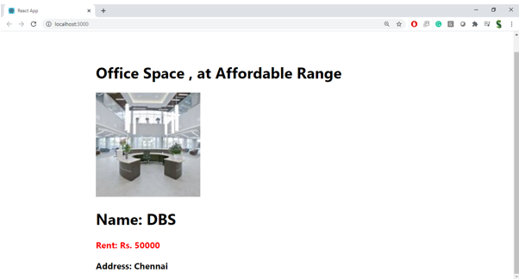

**Hint:**



